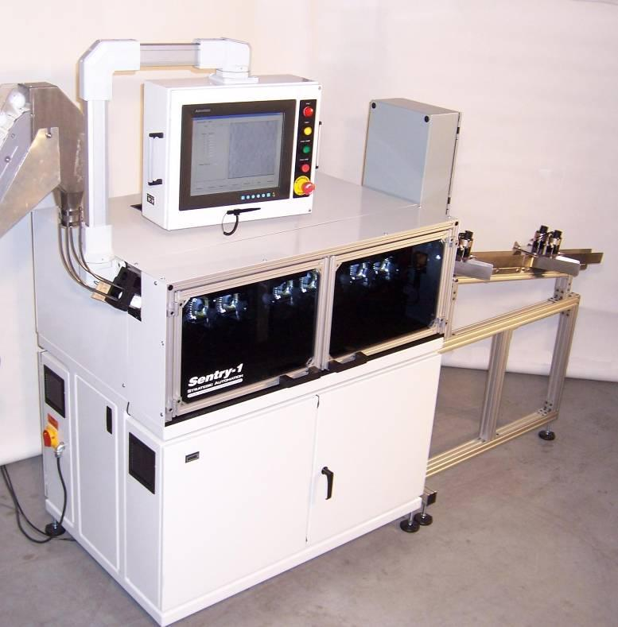
Sentry-1
Automatic Golf Ball Inspection Machine
Strategic Automation has developed the world’s first fully automatic golf ball inspection machine capable of matching the precision of the human eye. This machine is designed to inspect for various cosmetic defects in finished or unfinished golf balls. It has an operating rate of 30 balls/min. and can sort balls according to the type of defect found. An eight station, sequential operation allows for the detection of defects down to .003 inch square. It is easily trained to inspect different products and ball numbers. Once it is trained, an operator just selects a ball from a list and it is ready to run, unattended, as long as a supply of balls is presented to it. Defects are clearly displayed on the operator interface screen and the level of quality can be set to be as discerning as necessary. Contact Strategic Automation for a demonstration of the revolutionary new machine.

Advantages:
- Increased operator productivity. The machine can inspect 1200 dozen balls in a single shift.
- The machine maintains a consistent quality standard.
- Cameras and lighting are fully enclosed to minimize dust contamination.

Features:
- Inspects for Print Quality including missing ink, extra ink, poor color registration, and missing or incorrect printing.
- Inspects for Dirt Marks on the entire surface of the ball.
- Inspects for Discolorations (Haze) due to extraneous ink, bad paint, or bad cover material.
- Inspects for Surface Flaws such as nail marks, paint globs, holes, foreign material, and molding defects, incomplete paint.
- Inspects for Seam Flaws such as deep or shallow buffing, flashing not completely removed, torn sprues, etc.
- Inspects for Preferential Stamping flaws. That is, the side stamp did not get printed on the seam.
- Easily re-trainable by the end-user to run new ball types. Some dimple patterns may require additional software.
- Sorts balls to up to 4 categories (good and up to 3 categories of defects). Balls that did not get properly inspected are sent to a fifth bin to be recycled through the machine.
- LED lighting for long life and low power consumption.
- 15 inch color touch-screen operator interface display.

Optional Items:
- Custom offload designs to better fit the customer’s material handling requirements.
- Tooling and software for additional dimple patterns.
- Additional inspections required for individual customer’s needs.
- Hopper feed systems to deliver balls to the Sentry-1 inspection machine.

Specifications:
- Operating rate: 30 balls/min (typical)
- Resolution: .003 in.
- Inspection image: 550 x 550 pixels, 256 gray levels
- Number of cameras: 3
- Printed poles that can be inspected: 4
- Compatibility: 1.680 dia. Ball, most colors
- Power requirements: 120V, 1ph, 50/60 Hz, 7 amps
- Air requirements: 0.6 cfm at 90 psi
- Dimensions: 75H x 92W x 32D inches
- Weight: 850 lbs
- Warranty: 1 year

